Engagement Summary

Zero Waste BC conducted a workshop, a survey and a focus group in October 2023 to learn more about participants’ perspectives developing Metro Vancouver’s Vision and Guiding Principles for solid waste planning. The process and results are shown below.

# Workshop

An online workshop was held on October 5 from 11:30am-1:00pm. Invitations were sent to Zero Waste BC members and board members via email, as well as included in the email newsletter. An invitation was also sent to previous workshop participants. The workshop was promoted on Zero Waste BC’s website and social media via LinkedIn and Facebook, as well as through social media channels of SPEC, Climate Caucus, WECAN, and CityHive.

A total of 19 participants attended the workshop. There was a mix of representation, mostly from NGOs, which were over half of the participants (Figure 1).

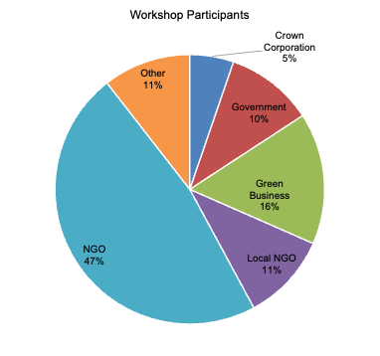

**Figure 1. Workshop Participants**

The format of the workshop generally followed the facilitation plan provided by Metro Vancouver including a review of themes identified by Metro Vancouver. Content was expanded to discuss the topic of zero waste more broadly, review the zero waste hierarchy and BC Ministry of Environment and Climate Change Strategy guiding principles, and consider links between waste and climate and environmental footprints.

The workshop opened with the question “What is zero waste?” Key themes of the participants’ responses were:

* A sense of responsibility for material that is generated and handled
* Thinking differently about what resources and materials are so they are valued
* Using a systems approach to avoid making waste and generally following the zero waste hierarchy to prioritize reuse before diversion

During the roundtable, questions were raised by participants related to engagement of stakeholders in the solid waste industry, embedding circularity into procurement for governments, best practices research on recyclable and compostable containers, and ensuring wood waste is not downcycled/combusted (and counted as recycling).

For discussions about the vision and guiding principles, participants were divided into 2 breakout groups. The notes and Miro boards were combined for the report, which are in Appendix A and include additional detail from the discussions.

The first discussion was an open question about participants’ visions for zero waste in Metro Vancouver. Key themes were:

* Responsibility of producers for their waste
* Culture change and embracing cross-cultural collaboration
* Equity and accessibility
* Having infrastructure and systems in place for local solutions
* Alignment with the Zero Waste Hierarchy as defined by the Zero Waste International Alliance (not just zero waste to landfill)
* Systems view and changing the paradigm of waste - prioritizing the higher levels of the zero waste hierarchy and making it easier to reduce, reuse, and repair
* Promotion and education to reinforce behaviour changes
* Data transparency, access, and full-cost/life-cycle accounting for all waste produced
* Partnerships to reduce waste

After participants reviewed the themes from Metro Vancouver and additional content, they identified missing items. The themes for missing items were:

* Metrics to track progress
* Ensuring all waste from the region is captured and not impacting the environment
* Maintaining public trust (related to recycling and end of life management) through clear definition of terms, data transparency and listening to communities, especially those who are low income and minorities
* Social and environmental benefits and incentives for local economies and communities to implement zero waste with a focus on the higher levels of the hierarchy
* Government support for reinforcing sustainability principles and pushing back against endless growth and expansion

Participants voted for their top and bottom three priorities. The themes/guiding principles that had the most votes for the top priorities were:

* Education and behaviour change - Changing how we think about waste and what we purchase
* Accountability and transparency for producers and consumers to reduce waste
* Affordability and accessibility of recycling and waste disposal options
* Reuse, repair, and thrifting instead of throwing things away
* Incentives for recycling and waste reduction - for businesses and individuals
* Product design and innovation - Designing products to be more circular and regenerative

Participants struggled to identify bottom priorities because they believed many of them are important. However, they did find that some themes/guiding principles were not worded clearly or should be better defined. The general comment was that these themes seem to guide conversations towards maintaining the status quo and are very vague.

In identifying the most important thing for a solid waste management plan, the following were key themes of the discussion:

* Systemic approaches focusing on upstream solutions to change product design and make it easier for consumers to reduce waste
* Promotion and education to ensure people understand circularity and zero waste
* Removing waste incineration as an option so that there is more support for reducing waste and finding alternatives rather than justifying waste generation
* Equity, justice, and accessibility so small players and equity-deserving groups can meaningfully participate in the circular economy
* Protecting the environment from toxic substances and materials
* Transparency of information from Metro Vancouver

## Workshop Evaluation

All participants were invited to complete a short workshop evaluation. A link was provided at the end of the workshop and sent in a follow-up email. Seven participants completed the evaluation. The evaluation form from Metro Vancouver was used.

Responses to the Likert scale questions are summarized in Figure 2. Participants generally strongly agreed or agreed with all the statements.

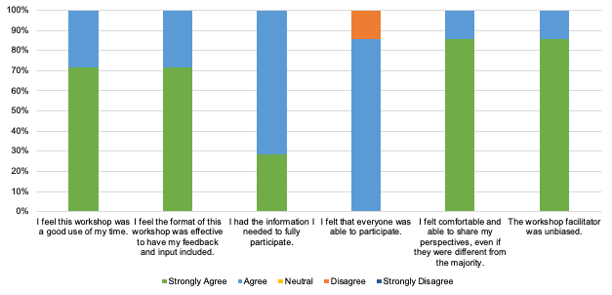

**Figure 2. Workshop Evaluation Responses**

In the open responses about one thing that went well in the workshop, participants liked how ideas were shared and the use of the online information sharing platform, Miro. They also appreciated the workshop flow and facilitation adaptation when the original plan was not working as well.

In the open responses about one thing that could be improved, the Miro board was noted as being challenging for some people to use. The presentation was seen as redundant for people with subject matter expertise. Participants also noted that some people spoke up or were more involved than others, and to increase the cultural inclusion and diversity of the process. There were suggestions for warm-up or icebreaker exercises for participants to get to know each other better.

# Survey

This survey was based on the Metro Vancouver survey, with additional questions related to zero waste. The survey was emailed to Zero Waste BC members and board members, as well as included in the newsletter. Reminders were also posted to Facebook on October 4 and 13. The survey was open from September 22 to October 15.

There were 6 responses to the survey. As there are few respondents, only general comments about participant demographics are included. Respondents to the survey all resided in Metro Vancouver and were mostly from Vancouver (67%). Half (50%) of the respondents reside in apartments/condos. All respondents are English speakers. The largest age demographic group was 19 to 35 (33%). Most participants identified as environmental advocates (67%). Further details are included in Appendix B.

In the first open question “What does zero waste mean to you?”, the responses generally referred to preventing waste, being responsible with material use, and keeping materials out of incinerators and landfills.

In the second open question “Why is zero waste important to you?”, there were mixed responses. Some themes were environmental sustainability and protection and the effects of waste on vulnerable communities.

In ranking the themes from Metro Vancouver, no respondents ranked any of the values and priorities as less or not important. Climate resilience and environmental stewardship were the most important priorities, selected by all respondents as very important (Figure 3).

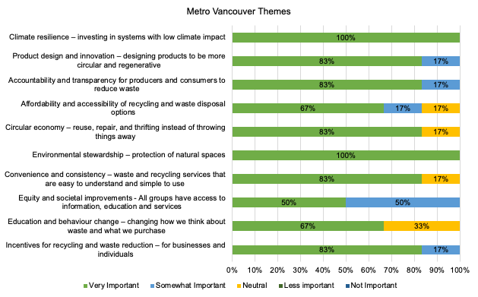

**Figure 3. Ranking of Metro Vancouver Themes**

Respondents also identified the following themes that were not included in the above question:

* Salvaging wood waste and biomass
* Costs and long-term impacts
* Space for private innovation
* Community development
* Renewable energy generation from waste
* More bylaws at the municipal and regional level

Respondents ranked the zero waste hierarchy levels from most (Rank 1) to least (Rank 7) important (Figure 4). Rethink/Redesign was highly ranked as the first (67%) and second (17%) priority. Reduce, reuse, recycle/compost were a mix, but generally ranked in the top half. Material recovery and residuals management were in the bottom half. Many ranked unacceptable (67%) as the lowest priority.

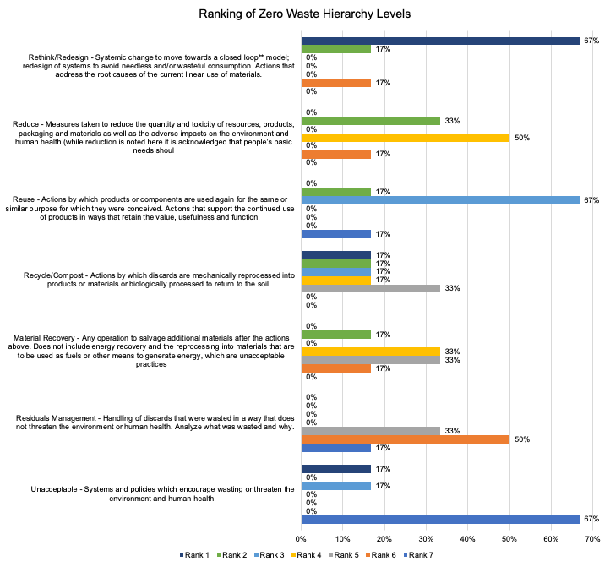

**Figure 4. Ranking of Zero Waste Hierarchy Levels**

# Focus Group

A focus group was held on October 12th. Participants were invited to the focus group directly and seven of the eight who wished to attend did so. The backgrounder and supporting information were sent to participants ahead of the meeting. There was a mix of representation by sector, as shown in Figure 4.

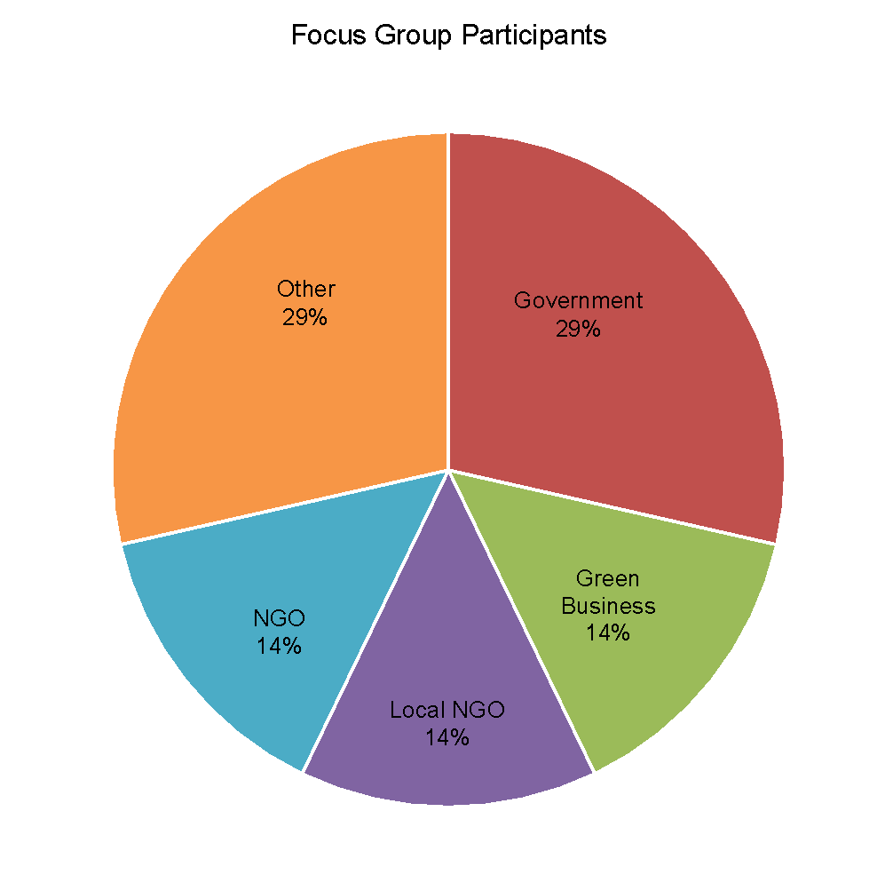

**Figure 4. Focus Group Participants**

After introductions, the focus group started with a brief presentation and opportunity to ask questions. Participants were asked to write down and then share their vision. Discussion ensued on the vision. The next step asked participants to select a guiding principle from the suite of options available across Metro Vancouver themes and guiding principles from the BC SWMP Guide, the Zero Waste Hierarchy and Metro Vancouver’s 2011 SWMP. They could also add new items or combine existing principles and themes. They were invited to discuss why they had selected given options.

Themes that emerged included:

* A focus on the first three Rs of the Zero Waste Hierarchy (rethink, reduce, reuse)
* The need for partnerships and collaboration based on trust, transparency and accountability
* Less emphasis on incineration and energy recovery
* Strive to make zero waste initiatives affordable, accessible and consistent
* Emphasize links to environmental stewardship, lowering carbon and environmental impact footprints and shifting to a circular economy (product design, extend product life, value management)
* Use a carrot and stick approach for behaviour change with enforcement

Detailed notes are included in Appendix B. Feedback on the process was requested by follow up email but no responses were received. Participants expressed appreciation for the invitation, event format and informative sharing session.

# Appendix A Workshop Results

Workshop Notes

Virtual or In-Person: Virtual

Workshop Date: October 5, 2023

# of Participants Registered: 30

# of Actual Participants: 19

# of event promotions: Direct emails to over 123 groups (including NGOs, academics, ZWBC Board and past event participants), included in newsletter, listserve, advertised on the website as well as Facebook and Linked in. Reminders sent.

|  |  |
| --- | --- |
| **Session** | **Participant Notes** |
| Summary of participants demographics from intros + organizations represented | * NGO - 9 * Local NGO - 2 * Green Business - 3 * Government - 2 * Crown Corporation - 1 * Other - 2 |
| What is zero waste? | * Being responsible for the material that passes through your custody * Refuse, reuse, recycle everything possible * Rethink, value resources, avoid creating waste * Full of opportunities for thinking outside the box in innovation in materials and approaches, materials reuse and repurposing, and diverting as much as possible out of the landfill waste stream. * Systems where waste is designed out, materials are chosen carefully and are easily recycled back into the same products at the end of their usefulness, single use is minimized to essential needs, toxic substances and problematic materials have been removed and very little recycling or waste to landfill or any other type of end of life management occurs. |
| Roundtable | * How are we bringing in or connecting people working on the industry side of things and not just players not on the table. How can industries start looking at circularity instead of just economics in dealing with procurement? * Who is doing the research on truly recyclable and compostable containers? How can I access "best practices" information? Concern about greenwashing that is occurring. * How do we also ensure we don't immediately downcycle things like wood waste into wood chips/compost? We are missing an incredible an environmental value + economic value of multiple life cycle stages before composting. |
| Vision | See Miro   * Stronger emphasis on waste producer responsibility - industry, manufacturing, etc. * We need to get the industry to participate. * Waste reduction strategies that acknowledge needed culture change. * Recognize that non-Western cultures actually have a lot of “sustainable” actions embedded because it’s just a way of life. Learn from Indigenous peoples and newcomers. Collaboration goes both ways. Embrace cross-cultural collaboration. * Look at consumption and the broader concept of consumer behavior * A plan that prioritizes equity and accessibility. * The plan applies equally to all the regions of Metro Vancouver. * More uniformity across the region for waste management and diversion. * A comprehensive plan that makes finding used materials easy, places to repair in neighbourhoods, and has more zero waste facilities available to the public. Provide clear guidelines on alternatives to the use of plastic. * Keeping solutions local. Designate municipal land within the city limits and provide below-market rent for diversion, reuse, upcycling and recycling infrastructure and industry. Ensure there is industrial land available for processing and that people living close to the facilities will not be negatively affected. * Process plastics locally. Do tours of facilities so people understand how recycling works. * Build off existing local knowledge. Need to integrate local innovators. * Align with land use and industrial zoning. Align Metro Vancouver plans. * Zero waste should mean that there is zero waste going to the landfill or incinerator (not just zero waste to landfill) - align with international, peer-reviewed Zero Waste Hierarchy rather than going in the opposite direction (incineration is in the Unacceptable tier) * Thinking about systems as a whole and people's lifestyle choices. * Prioritize refusing, repurposing, reusing, reducing and developing cradle to cradle systems change. * Rethinking systems at all levels of government and industry to embed zero waste principles. * Value resources. * Lots of promotion and engagement: pop-ups, opportunities for the community to learn about what zero waste means, getting community buy-in * Education to get people to understand environmental costs of single use * Education to move away from reliance on “recycling” * Make reuse most cost effective * Regional access to reuse systems - backhaul and sanitization * Make finding used materials easy, repair in neighbourhoods, zero waste facilities for public * Increase compostables and supporting infrastructure * Waste/resource information and access * Transparency for recycling * Increase partnerships between organizations to reduce waste * Encourage businesses (green/non-green) to be sustainable * Full accounting for all waste that may be produced, including microplastics * Consider full life cycle analysis for product when making decisions on materials |
| Missing items | See Miro   * Need better metrics on how we are tracking progress. Measurement and monitoring needs to inform policy for waste reduction and progress. * Solid waste infrastructure needs to ultimately capture all the waste in the region and prevent it from going into the environment. * Value not just consumer goods, but also organics and biomass. * Be transparent about what the terms mean. Define what is included in recycling and composting. Does recycling include chemical recycling? If we are talking about continuing recycling, are we eliminating things that could be reused? * Local economies are struggling- they need govt. support to sustain costs- we need to sustain local companies and make them feasible- local economies as a concept is too overarching- for example- how to make a local cafe that focuses on reusing and repairs- sustainable entrepreneurships- we need to make sure they sustain- **restorative cities and economies-** instead of micro-cleaning- low-barrier jobs in circular economies. Social and environmental benefits are included- it also includes financial benefits for small businesses trying to start and maintain work. * Governments need to publicize and promote environmental initiatives more. * How to regulate industries or residential sectors in a community when it relates to industry talks only about growth and expansion and these values don’t fit with the idea of sustainability? Governments support capitalism which is fundamentally against the ideals of sustainability- “endless growth”- should be criticized. * We all want to push to reuse- how to overcome barriers to reusing material in the construction industry. Also, actively listening to community members and making them feel heard is extremely important- transparency in building trust is important * Addressing cost barriers to communities. Materials are sometimes dumped because transportation and other fees of taking them to other places are too expensive- regulations must be shaped to change this. Opportunity for **future advocacy** with NZWC giving MV a voice at the federal level- involvement in the national discourse and ability to voice local concerns. * Businesses might need incentives for engaging in sustainability * Cost of land challenge- struggle to keep upcycling spaces open and offer their services because of expensive rent etc.- also expensive to transport materials to various spaces. It takes a lot to change behaviour and systems. * We are talking a lot about community. Engagement- we need to build trust- environmental justice lens- low income and minority communities- need to respect and understand the systems already run by these local communities and minority groups- need to respect and understand them instead of pushing top-down policies on these areas. Build on what exists |
| Top priorities (3) | See Miro  Education and behavioural change: A lot of work is about behavioural studies. A lot of people in BC do a lot of these sustainable actions, but the motivation is not sustainability. It’s just their way of life. Actions are good for the planet, but may not be intentional. Saving, repairing, making use of what they buy, getting money’s worth - these are values that we need to consider to engage more people who might not care as much about the environment. Behavior change can greatly influence people and direct them in the way that brings a sustainable future.  Accountability: Having more accountability (Producers and consumers)-tackling the problems from both sides- can also propel further initiatives  Incentives: What incentives can be given to industries to form better designs. Bylaws/provincial bylaws might be beneficial for assisting with these circular economy strategies  Product Design: Example - neighbourhood bike showcase- information awareness to the public can help the public know which product is more sustainable or better for the public. |
| Bottom priorities (3) | See Miro  Facilitator's note: Participants struggled to identify bottom priorities because they believed many of these are important. They did find some of the priorities are not worded clearly, or need to be better defined. These are indicated with YELLOW stars.  General comment: There are implicit assumptions behind these themes from Metro Vancouver that guide conversations in a certain way towards maintaining status quo. What can we do about that?  Opportunity costs: Need to be aware of sunk cost effect with government policies. Can’t let those define future actions that may be more costly.  Highest and best use: Makes a lot of circular things less feasible- looking at it from land use and not material use perspective. |
| The most important thing for me…. | See Miro  Systemic approaches focusing on upstream: Massive part of waste is plastic. We have spent decades educating consumers to be better consumers. Producers are making hundreds of different types of plastics. A lot of recycling goes to the transfer station and then goes to garbage because those hundreds of types of plastics are not all recyclable. We are focusing on individual people and putting investment in them to sort materials properly. Better at focusing upstream at the producers and changing what comes down at the people.  Promotion and Education: Encompass community and make sure people understand what circularity and the 3Rs are. Change happens with knowledge  General question: Why don’t we synthesize these several vision pointers and instead build 3 or 4 broad ideas or visions?  No Incineration: Waste incineration shouldn’t be an option because it justifies waste. Removing it as an option will push for reducing waste and thinking of alternatives.  Coordination between divisions: Are there other plans? Liquid waste? What happens to biosolids? |
| Summary of participants interests | * Emphasis on upstream values and prioritizing the top tiers of the zero waste hierarchy - systems change starting from producers, not the consumers * Trust and transparency - clearly define what different terms mean to Metro Vancouver rather than hiding assumptions, make it publicly available what is happening with waste materials, where they are going, and the environmental and societal impacts * Having the local infrastructure and systems to ensure items and materials stay local through supporting local innovators and local businesses * Education and behaviour change needs to consider non-Western paradigms and learn from the diverse cultures in Metro Vancouver |

Consolidated Miro Boards are shown below



MV themes

New additions

BC SWMP Guidelines

ZW Hierarchy

Note that green stars show which principles people included in the top three, red are bottom while yellow needed edits.

# Appendix B Survey Demographic Details

67% Vancouver

17% District of North Vancouver

17% West Vancouver

50% apartment/condo

33% detached

17% no answer

All English speakers.

33% 19-35

17% 36-52

17% 53-65

17% 75+

17% no answer

Representation (people could check multiple options):

67% environmental advocate

33% environmental organization

17% green business

17% concerned citizen

17% educator

17% industry worker

# Appendix C Focus Group Results

Focus Group Notes

Virtual or In-Person: In Person

Focus Group Date: October 12, 2023

# of Participants Registered: 8

# of Actual Participants: 7

|  |  |
| --- | --- |
| **Session** | **Participant Notes** |
| Roundtable Questions | * Where is “refuse” (as in to refuse an item) in the hierarchy? A. in rethink/redesign. |
| Vision | * Follow the ZWIA hierarchy and definitions (NZWC does not define ZW, nor have principles, support international movement for ZW) * Promote hierarchy for ZW * Needs a shift in mindset to move beyond management * Focus on reuse, repair, repair * Closed loop systems, reuse where possible, policies to support this * Share sheds, lending libraries * Focus on high impact materials in the waste stream * Classified properly, extend life of product * Clarity on terminology for reuse, recycling, etc. * Facilitate connections (like industrial symbiosis) * Supportive of local business in 2 parts, 1. businesses involved in waste/recycling/reuse and 2. regular businesses subject to policy * A Metro Vancouver where going zero waste is simple, clear and the norm * Could it be easy * Simple convenient system that directs residents to pyramid -make it easy * Deep transparency around where materials go and easy to understand * Businesses trying to do the right thing -compostable materials -certification/labelling * Need to be clear on what is classed as recycling ( e.g. wood burned at pulp mills, etc. is called recycling). Need to force industry to do something better. * Stop focusing on recycling as a silver bullet. * No burn no bury - push for urgency, and systems change * What the vision should not include: Biosolids to incinerators, to add more throughput; bottom ash to cement; wood burning on Coquitlam site; district energy using waste to energy * Promoting successes (like Recycle BC -plastics) * Lean in to what is going well * All materials are valued, not how to get rid of something I do not want /need |
| Guiding Principles –  The group was shown the Metro Vancouver themes, the principles from the ZW hierarchy, the provincial guiding principles and the principles from the previous plan. Asked to start talking about the most important ones to them. Shown to the right in rough order of importance | * Opportunity cost -consider what is not being done while choosing other actions to pursue (example. time, money and effort wasted in pursuing expanded incineration in last plan instead of more waste reduction measures) * Need for partnerships -so much could be done if the community gets on board * Transparency + Accountability (cement kilns for example -not same regulations and standards), erosion of public trust and motivation to take action when it feels like it is not clear if it is making a difference * Local economy -need to reserve industrial land, NADA closed, need private businesses not being supported), could be treated out like for north shore organics contract instead of supporting a good local business -net local benefit + * Highest and best use of materials * Process close to source -reuse is closest * First 3 Rs -rethink, reduce, reuse (thought recycling was getting too much focus, need to have first three be rethink/reduce, reduce and reuse). Keeping products in use by the original owner as long as possible * ZWIA standards for ZW to be used -align with international standards * Partnerships built around a positive goal * Affordability and accessibility -including for reuse. Reframing it, awareness of other cultural practices, bulk should not be more expensive. * Convenience and consistency -not just for waste and recycling but across the full hierarchy (e.g. reuse, repair, etc.) * Education and behaviour change to bring people along. Carrot and stick -have people understand what they are already paying for in terms of taxes, etc. as well as environmental/social harms * Equity and societal improvements * Highlight businesses opportunities/jobs from zero waste * On site and community based - supporting local business * Resilience-climate-infrastructure but also systems and processes * Promote Zero Waste and Circular Economy * Public health/equity -needed as history of pushing negative consequences to poor communities. * Prevent organics and recycling going to garbage -inspect each load, open bags * Salvage for reuse -highest and best use * Precautionary principle -discussion on why it is important (example. use of bottom ash in concrete) * ZW principles -depends on how they define it -use ZWIA principles * Information and improvement -need to monitor metrics and provide clear feedback to all to help drive change, transparency is important for this as well * Support reuse, repair, thrifting (note that CE is not defined as only these actions so perhaps remove confusing label) * Environmental stewardship -good lens -**responsibility to** natural spaces as well as environment in general (air quality, water quality, not polluting) * Process and consultation -need to all be aligned (processes including RFPs) * Product Design and innovation-is needed * Convenience and consistency -make it cheaper to do the right thing for businesses -ensure feedback is going back to generator, not hauler; ensure haulers are doing the right thing * Polluter pays/user pays -could be stronger. Acknowledge externalized costs * Level playing field -generators and haulers * Missing: Enforcement of policies (like organics, disposal bans)   Comments:   * Need to make sure these principles flow through into purchasing/operations, etc. as this has not been the case to date. Need radical rethink of RFP processes at Metro Vancouver * Caution with “materials as resources”-if it is used to push for incineration * Some parties may be more willing to partner and work together on zero waste if incineration was not on the table (Example. flow control is a good measure but not to shore up materials for incineration). Previous plan’s focus on incineration and the way the previous consultation was handled led to distrust of Metro Vancouver. * Caution around “not exporting waste” as can be used to justify incineration. Do not export harm– how to define, caution around dispersing materials. Noted that could export materials but needs to be to a location that welcomes them and has the capacity to deal with them safely and in an environmentally sound way   Ones not supported:   * Energy recovery, 5Rs inc energy recovery * Integrated resource recovery * Aligning with other plans should not be an absolute -may not have alignment so aim for SWMP to be progressive (even if not aligned).   Others were not disliked but not flagged:   * Sustainability * Natural/social/economic capital * Minimize discharges * Conservation of energy * Materials are resources (not energy) * Closed loop systems * Collaborate with other RDs * Develop collaborative partnerships * Maximize use of waste materials and manage residuals appropriately |
| Summary of participants interests | * Working on the first three Rs of the ZW hierarchy and collaboration on this * Broader reach of actions * Building trust which will be needed for the partnerships and collaboration * Less focus and resources on incineration |